Main Agenda- To read a report definition through activity and export and send email as a PDF

For this we need activity and report and then call the report into the activity and then create a section and then we need an email account for it and then we need the SMTP server port from the account and then an email automation step and then the attachment category and mention it as a file and then go for the call in the post-processing of the flow action.

First, we can do customization in the google account go to settings

In this IMAP enable the IMAP here and then go to the security tab and then go to the app passwords

And then enter the google password and log in

Go for Pega and then click generate

Then a code would display

And then copy the code and keep it and now can configure the email account from which you want to send to the email and go to integration resources > email account

And in this, we can give the email provider as google Gmail and this give the send using the tag as SMTP and then give your email address and display name and then go for the user ID also as Gmail ID and give the Port as 587 this is default given SMTP port by google

And authentication can give as the code generated given by google and this is all done under the Sender and then the same thing in the receiver

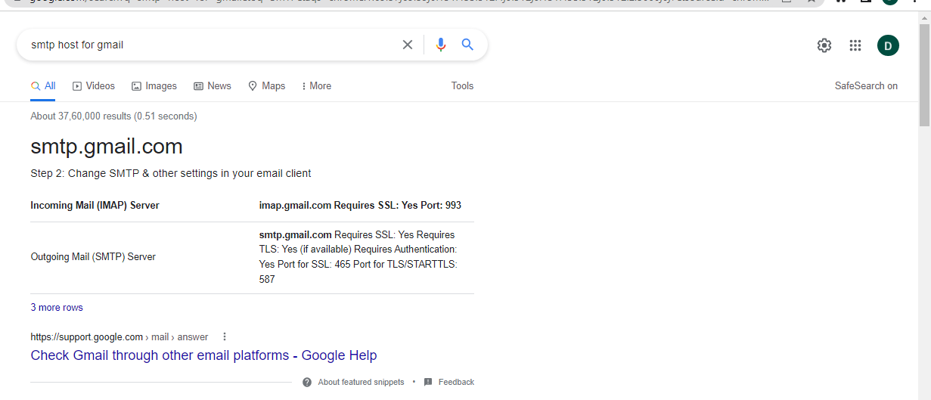

And then create one report and give it to the receiver and the sender of the email after all these configurations it would look as the below

And now go for the report generation

I created the section rules

And then to read this report through activity go for the activity to call the report and get it into the pdf

In the activity, we have to call the report in the first step and then go for the pxRetrieveReportData and use the call method under that give as the report name and report class in that step

And now call the pxCreatePDF OOTB activity inn the second step to get the generated PDF and in that can give the section name and PDF Name and use the attachment category as file this would be used by Email to get the pdf in the email.

And now to give here we need the section and then go for the section and then go for the source as report definition in which your report is called under a table layout and give it under the section name and get this

And then give the section name and name which should be display the PDF Name and attachment category as File 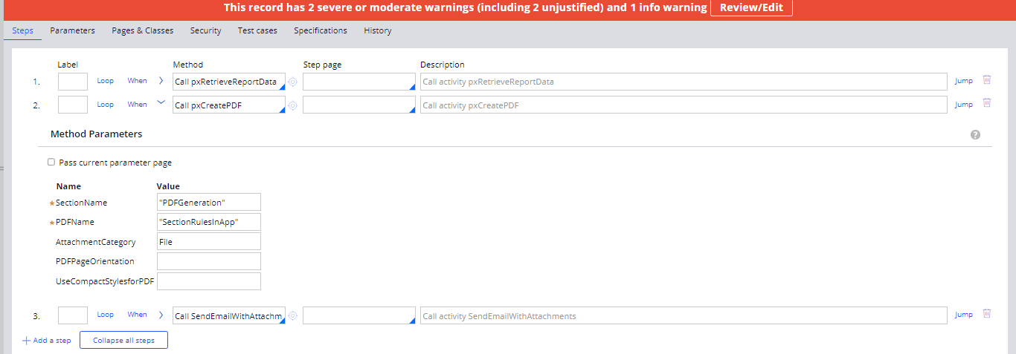

And then go for the another OOTB as send email with attachments

And then give the To address gmail and from address and subject and give the password generated by the google and given to us by gmail which is the password

And then go for the giving this password there in the activity and then the smtp host as the 465 same as given in the email account configuration and now go for the case flow and mention this activity in the post processing flow

And then go for the action and in the action give as the subject and give the run activity and give your activity

And for the attachment in the case type give them as the include attachment in the category and specify it as the file and then can create the case and check for your gmail that it is sent or not.

And now can check in your account

and the pdf is displayed in the gmail we can check this in clipboard also

And under the pyWorkPage we can find link Attachment

